Day 3: Combinational and Sequential Optimization
Welcome to Day 3!
So far, we’ve learned how to simulate and synthesize RTL designs. optimization — techniques that help make circuits smaller, faster, and more power-efficient. Both combinational and sequential designs can be optimized, and we’ll explore some common methods along with hands-on labs.

Agenda
- Constant Propagation
- State Optimization in FSMs
- Cloning for Load Balancing
- Retiming of Registers
- Lab Experiments (6 mini-exercises)

1. Constant Propagation
This technique detects constant values in the design and pushes them forward through the circuit.
How it works:
- The tool scans the code for signals that always hold fixed values.
- Those signals are replaced with constants.
- As a result, large portions of logic can get simplified or even removed.
Advantages:
- Less logic → fewer gates → smaller area
- Shorter paths → improved speed
- Reduced power and resource usage
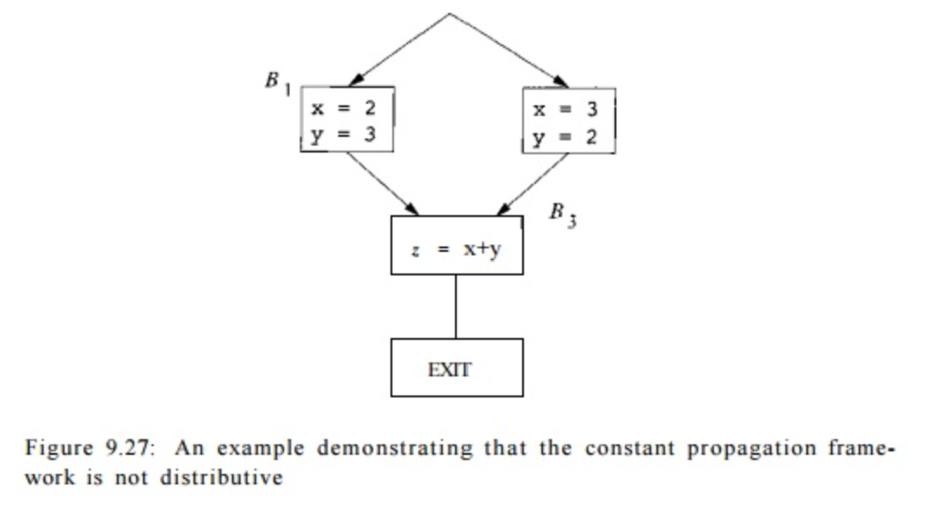
2. State Optimization
Finite State Machines (FSMs) often carry redundant states or inefficient encodings. State optimization tackles this.
Main steps:
- State Reduction: Merge states that behave identically.
- Encoding: Use efficient state codes (binary, Gray, one-hot, etc.).
- Logic Minimization: Apply Boolean simplification.
- Low-Power Design: Techniques like clock gating reduce unnecessary switching.
End result: more compact FSMs that consume less power and silicon.

3. Cloning
Sometimes a single gate or module drives too many loads, creating long delays. Cloning fixes this by duplicating that logic and distributing the fanout.
Process:
- Identify critical nets with high delay.
- Duplicate (clone) the logic cell.
- Split loads between original and clone.
- Verify timing and power improvements after placement and routing.
Effect: Shorter wires, lower delay, and balanced load distribution.

4. Retiming
Retiming is a powerful optimization for sequential circuits. It involves moving registers (flip-flops) across logic without changing functionality.
Steps:
- Represent the circuit as a graph.
- Shift registers forward or backward to balance delays.
- Ensure setup/hold timing constraints remain satisfied.
- Achieve reduced clock period (higher performance) or lower power.
Think of it as "shuffling registers around" to smoothen performance bottlenecks.

5. Lab Experiments on Optimization

Lab 1: Constant Propagation with Multiplexer
module opt_check (input a , input b , output y);
assign y = a ? b : 0;
endmodule
- If a=1, y=b.
- If a=0, y=0.
- The optimizer replaces this with simpler logic.
Run synthesis and before abc -liberty, insert:
opt_clean -purge
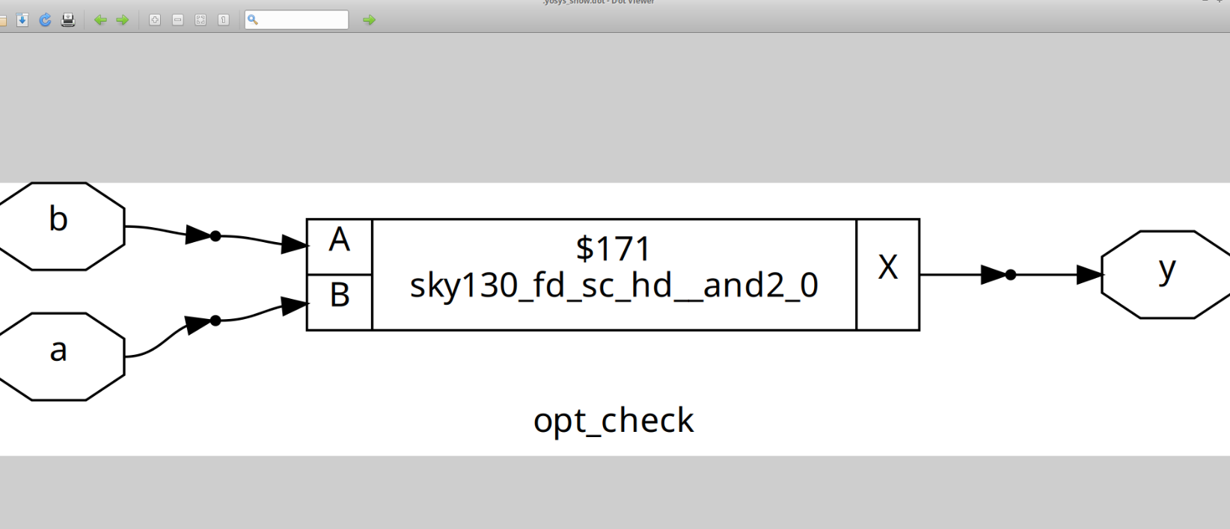
Lab 2: Multiplexer Simplification
module opt_check2 (input a , input b , output y);
assign y = a ? 1 : b;
endmodule
- Works like a mux:
  - y=1 when a=1.
  - y=b when a=0.
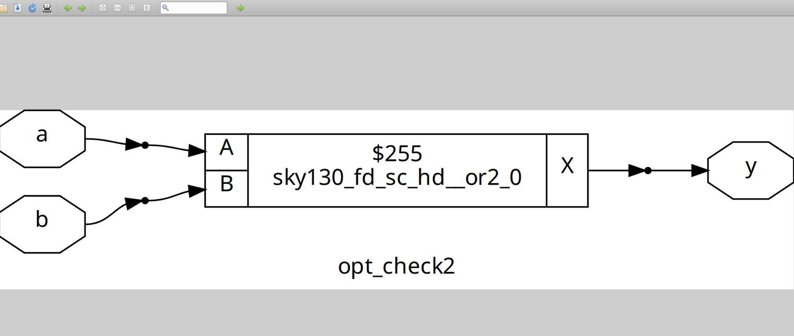
Lab 3: Another 2-to-1 Multiplexer Form
module opt_check3 (input a , input b , output y);
assign y = a ? 1 : b;
endmodule
- Equivalent to Lab 2.
- Simplifies to a mux that chooses between constant 1 and b.
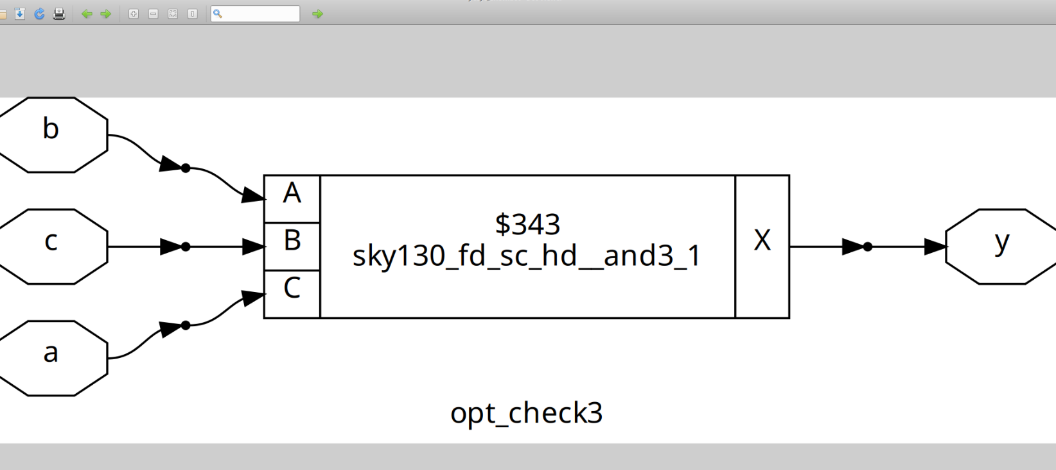
Lab 4: Nested Ternary Reduction
module opt_check4 (input a , input b , input c , output y);
assign y = a ? (b ? (a & c) : c) : (!c);
endmodule
- Step-by-step simplification shows this reduces to:
y = a ? c : !c;
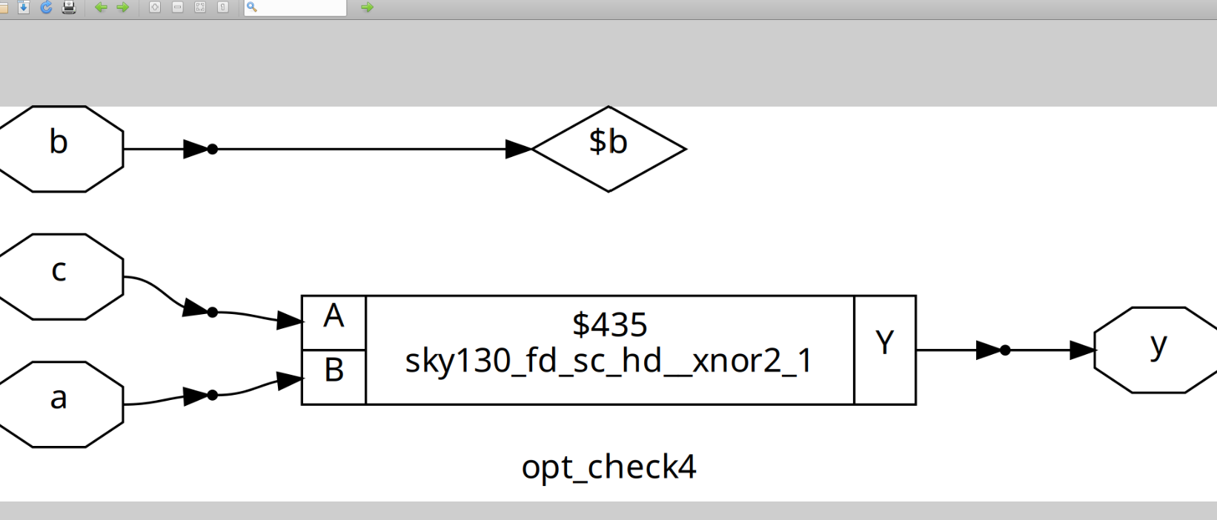
Lab 5: D Flip-Flop with Constant Data
module dff_const1(input clk, input reset, output reg q);
always @(posedge clk, posedge reset)
begin
if(reset)
q <= 1'b0;
else
q <= 1'b1;
end
endmodule
- Reset clears q=0.
- Otherwise, the flop always loads 1.
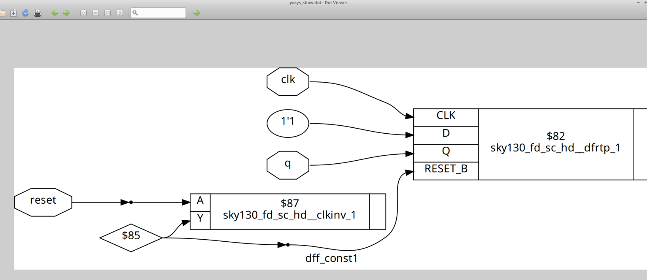
Lab 6: D Flip-Flop Always High
module dff_const2(input clk, input reset, output reg q);
always @(posedge clk, posedge reset)
begin
if(reset)
q <= 1'b1;
else
q <= 1'b1;
end
endmodule
- No matter what, q is always 1.
- Synthesizer will likely optimize this away to a constant net.
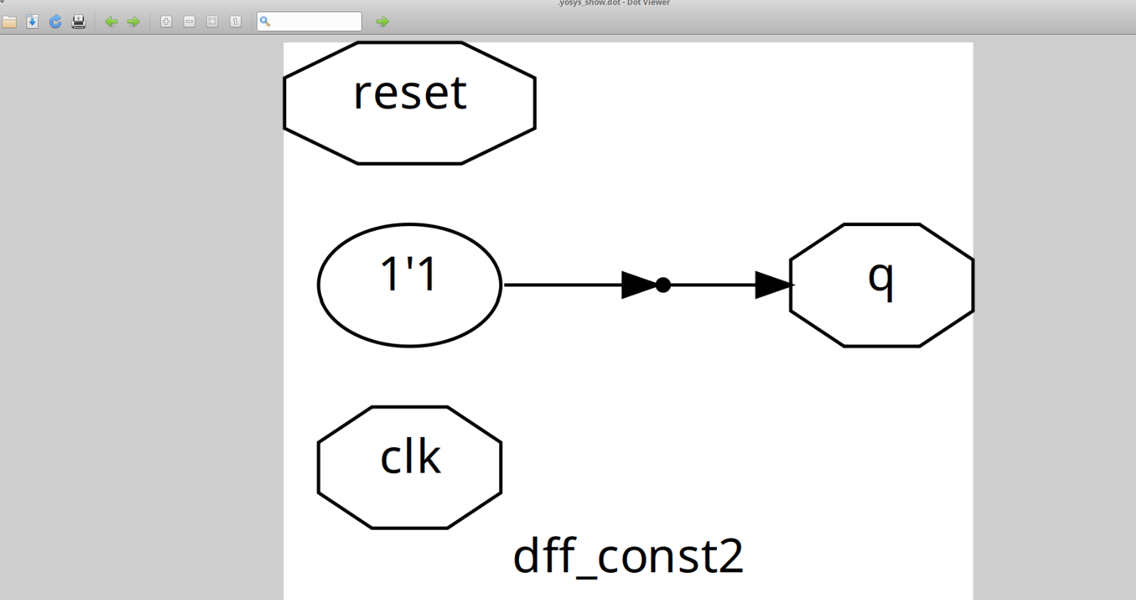
Recap
- Constant Propagation → replace constants for simpler circuits.
- State Optimization → reduce redundant FSM states and logic.
- Cloning → duplicate logic to balance loads.
- Retiming → reposition registers to improve timing.
- Labs → saw how optimization changes real Verilog code.

